

**WYNNUM RUGBY CLUB SCOREBOARD**

Contents

1. INTRODUCTION 2

2. POWER AND SAFETY 4

2.1. WARNINGS 4

2.2. CIRCUIT BREAKERS 4

2.3. LED POWER SUPPLIES 4

2.4. POWERING UP 4

2.5. CONTROLLER BATTERIES 4

3. SCORE DISPLAY OPERATION 5

3.1. HANDHELD & WIFI CONTROLLER 5

4. SPONSORS DISPLAY OPERATION 8

4.1. OVERVIEW 8

4.2. SOFTWARE 9

4.3. SETUP 10

4.4. UPLOADING 12

4.5. SPONSORS GRAPHICS 12

5. BLOCK DIAGRAMS 13

5.1. SCORE DISPLAY LOGICAL LAYOUT 13

5.2. SCORE DISPLAY POWER LAYOUT 14

5.3. SPONSORS DISPLAY LOGICAL AND POWER LAYOUT 15

5.4. MASTER & PANEL MICROPROCESSOR PCB 16

5.1. WIFI CONTROLLER PCB 17

6. HARDWARE AND PARTS 18

6.1. SCORE DISPLAY 18

6.2. SPONSORS DISPLAY 19

6.1. WIFI CONTROLLER 20

7. DESIGN FILES 22

8. PROGRAMMING 22

8.1. SOFTWARE DEVELOPMENT ENVIRONMENT 22

8.2. SOFTWARE LIBRARIES 22

8.3. SOURCE CODE 22

# INTRODUCTION

The scoreboard has two displays:

* **Score Display** – two numerical displays at the top left and right of the scoreboard
* **Sponsors Display** – a long area at the bottom of the scoreboard to display scrolling text or graphics (e.g sponsors names)

The score display and the sponsors display are physically separate and use different controllers (i.e. they are not interlinked).

|  |
| --- |
| C:\Users\Dave\Dropbox\Camera Uploads\2016-07-16 13.58.36.jpg |

# POWER AND SAFETY

## WARNINGS

**The scoreboard is powered by 240VAC and has lethal current inside. The back access panels must be secured and locked shut at all times.**

**If the scoreboard is powered from a generator, you must connect an earthing stake to ensure that the safety switch will function correctly.**

**The scoreboard is resistant to some moisture, but is NOT suitable to be operated in wet weather.**

**In high wind, position the board facing 90 degrees (narrow side on) to the direction of the wind.**

## CIRCUIT BREAKERS

There is a circuit breaker and safety switch box inside the back left access panel that allows the displays to be powered individually. If the safety switch has tripped for any reason you must consult a qualified electrician.

The key to the scoreboard rear panel doors is attached to the hand-held controller.

## LED POWER SUPPLIES

The LED panels are powered by five 5V 40A power supplies inside the display. If a group of LED panels is not lit up, refer to the Support section below.

## POWERING UP

To power up the scoreboard connect a 240VAC lead to the power inlet on the right hand side of the scoreboard.

After power on:

* the Score Display will show a short test pattern. If any individual LED’s do not light up, refer to the Support section below.
* the Sponsor Display shows a splash screen (“Wynnum Rugby” or similar) that may be configured as described in Section 4 below.

The unit must be grounded - either using a normal 3 pin electrical lead or a ground

**If the scoreboard is powered from a generator, you must connect an earthing stake to ensure the safety switch will function correctly.**

## CONTROLLER BATTERIES

The hand held controllers are battery powered – see instructions below for changing the batteries.

# SCORE DISPLAY OPERATION

## HANDHELD & WIFI CONTROLLER

### Overview

The WIFI Hotspot controller provides two separate modes of operation:

* dedicated buttons to manually increment or decrement the score
* an integrated WIFI hotspot allowing control of all scoreboard features.

### Power

The unit is powered by a rechargeable 1000Mah Lithium Polymer battery that should last for at least two or more full games of continuous use. If the battery runs low during a game, it can be plugged in and charged while still controlling the scoreboard.

To recharge the battery connect a standard USB Type B plug to the external socket – allow around 3 to 4 hours to fully charge. The battery has built in protection for over-voltage and minimum state-of-charge.

**WARNING – It IS NOT RECOMMENDED TO LEAVE THE UNIT CONTINUOUSLY CHARGING – DISCONNECT THE CHARGER AFTER THE CONTROLLER IS FULLY CHARGED.**

### Indicators

The hotspot controller has an LED on the front panel to indicate its status:

|  |  |  |
| --- | --- | --- |
| **Display** | | **Meaning** |
|  | Long flash every 2 secs | Low battery – charge immediately (less than 20% remaining) |
|  | Short flash per second | Error – no signal or out of range – move closer |
|  | Short flash per second | Normal – sending or receiving score data |
|  | Short flash occasionally | Normal – sending or receiving WiFi data |

NOTE: Different patterns may ‘mix’ together - for example – if the hotspot controller is connected however about to run out of battery, expect to see the LED flashing red and also blinking green once per second)

### Connecting to WiFi

After powering on the controller, it will automatically establish communications with the scoreboard. To connect to WiFi:

* Stand near the handheld controller (within about 20 metres) and turn it on
* Open WiFi settings on your phone and select the SSID called “Scoreboard”
* Enter the password (at the time of writing the password is “MightyBugs”). The password is case-sensitive.
* After your device has successfully connected to WiFi, open a web browser and navigate to <http://scoreboard> . The web-page controls are fairly intuitive/easy to operate:

|  |
| --- |
| **Wifi Controller - Main Page (Landscape mode)** |
| **Wifi Controller – Settings Page (Landscape mode)** |

### Controller Placard

The controller has a placard inside the front cover with instructions as follows:

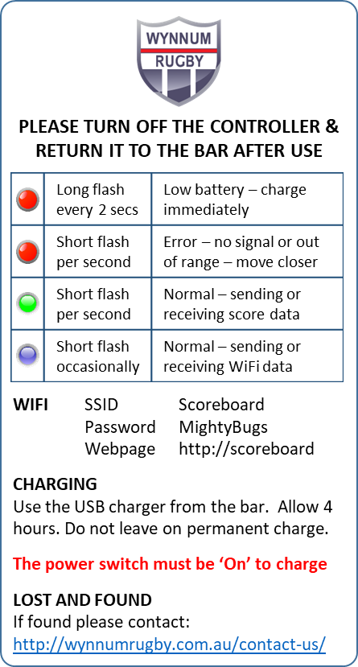

# SPONSORS DISPLAY OPERATION

## OVERVIEW

The sponsor display is area of 7 x 3 panels (224 x 48 blue LED’s) controlled by a commercially available Huidu HD-W6B Single Color Controller at <https://www.huidu.cn/product_116.html>

The W6B has:

* Wi-Fi hotspot to update programs by Wi-Fi connected
* USB port to upload programs by exporting to a thumb drive

The display is preset using a laptop and normally runs on an automatic loop showing sponsors names (i.e. it is not operated by the handheld controller).

Specs are:

|  |  |
| --- | --- |
| **Contents** | **Parameters** |
| Support module | Single Color/ Dual Color /Tricolor conventional scanning methods |
| Control range | Single color: 1024*48 / Dual color: 512*48 |
| FLASH Capacity | 4M Byte |
| Communication Port | U-Disk & Wi-Fi |
| Support Colorful | Full-color module can display red, green, blue, yellow, purple, green, white |
| Program Quantity | Max 1000 programs. Can play by time section or control by buttons. |
| Area Quantity | 20 areas with separate zone, and separated special effects and border |
| Display Showing | Text、Picture、3DText、Animation（SWF）、Excel、Timing、Temperatures（humidity）、Count、Lunar calendar |
| Display | Sequence display, button switch, remote control |
| Display effect | 1、Text、Picture, Time, Timing 、Temperature or temperature and humidity (external module required) Display  2、Support program border, regional border settings, custom borders  3、A variety of action display  4、More than 40 kinds of text effects display  5、Support for simple animations word  6、Support outline fonts, stroke fonts and other settings  7、Support for regional text background settings  8、Support Excel form directly adding |
| Clock function | 1、Support Digital Clock/ Dial Clock / Lunar Time/  2、Countdown /Count up, Button Countdown / Count up  3、The font、size、color and position can be set freely  4、Support multiple time zones |
| Extended Equipment | Temperatures、Humidity、IR Remoter、Photosensitive sensors、etc. |
| Automatic switch screen | Support timer switch machine |
| Dimming | Support three brightness adjustment mode |

## SOFTWARE

### Download the HD2020 Software

The software to program the board is called HD2020 and is free to download from <https://www.huidu.cn/download/128.html?page=1>

With modern PC’s and High Definition displays the scaling of the user interface can be tiny – within Microsoft Windows right click on the shortcut to find the settings for **Windows Compatibility mode**

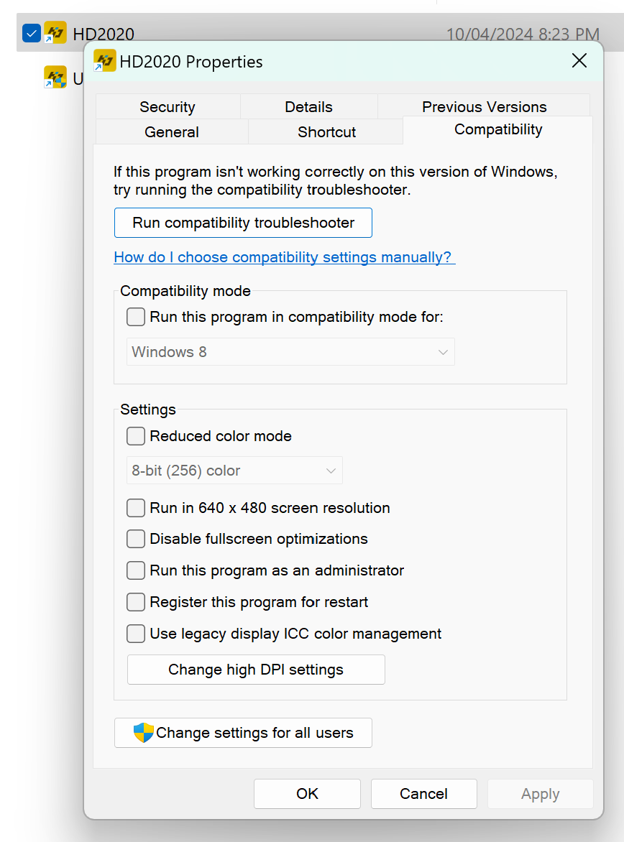

Change the “High DPI Scaling override” to “System” that should (probably) fix the user interface scaling issues.

### Download the Sponsors Files

To download sponsors files from Github:

* Go to <https://github.com/plainolddave/Scoreboard>
* Navigate to the “*Sponsors*” folder for the most recent year and download everything – you’ll need all the files unzipped onto your hard drive for the following steps.

### User Manual

There is a user manual for HD2020 on Github at <https://github.com/plainolddave/Scoreboard/tree/master/Manual>

## SETUP

### PROGRAM CONFIGURATION

After installing the HD2020 software and downloading the latest sponsors program folder from github, <https://github.com/plainolddave/Scoreboard/tree/master/Sponsors> , load the file called ‘*Scoreboard.xml*’

If this is successful you will see the screen as below, with all the sponsors programs on the left:

### CONNECTING

With the scoreboard powered up – connect a PC to the inbuilt WiFi access point:

* **SSID:** W6B_XXXXX (random letters and numbers)
* **Password:** 88888888 (that’s eight 8’s)

You should see the W6B controller Device Name appear as shown below:

### 

### ADVANCED SETUP

For reference the settings for the scoreboard are as follows - it is very important these settings are not altered.

### Screen Parameters

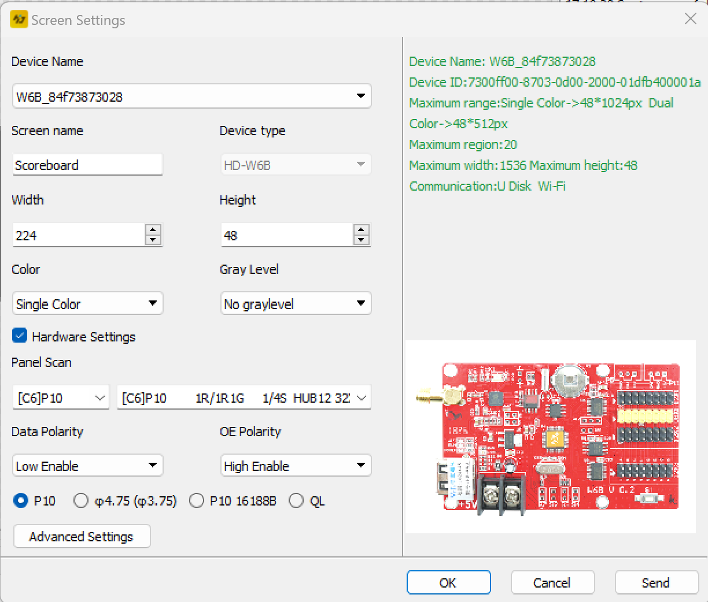

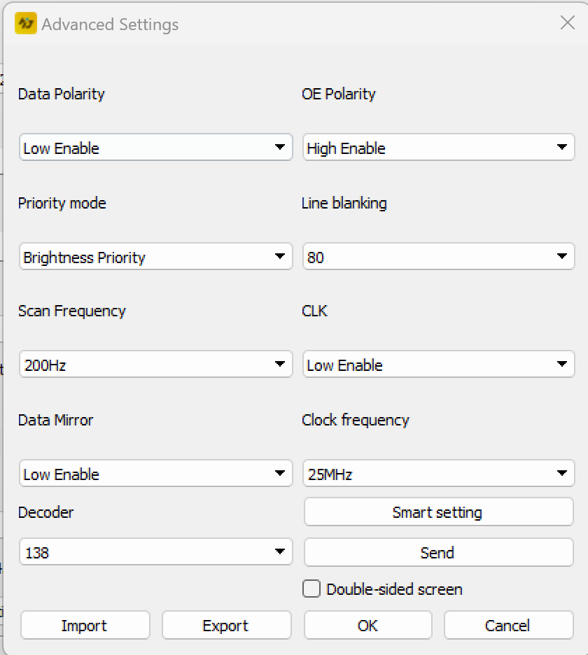

## UPLOADING

To upload press the green ‘Send’ icon



Alternatively you can upload using an USB (see instructions in the pdf manual).

Uploading takes only a few seconds – when it is complete the controller will reboot and immediately show the uploaded program.

## SPONSORS GRAPHICS

To prepare sponsors logos:

* images look best if they are formatted as a bitmap up to 224 x 48 pixels with 1 bit color depth.
* complex logos may need to be hand-drawn using a graphics editor (GIMP, Photoshop etc)

Logos for each year are in the *Sponsors -> Sponsors[Year] -> Logos* folder.

For example:

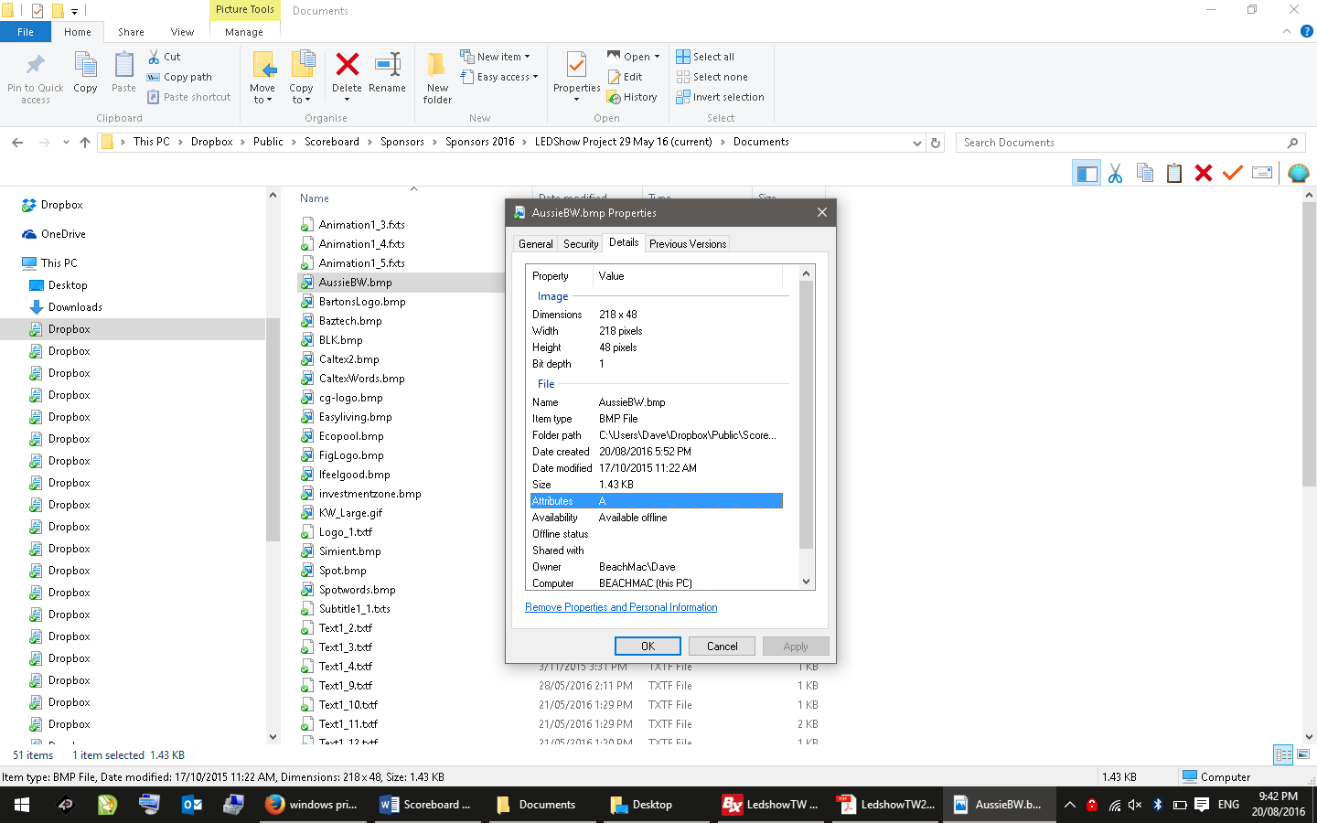 

# BLOCK DIAGRAMS

## SCORE DISPLAY LOGICAL LAYOUT

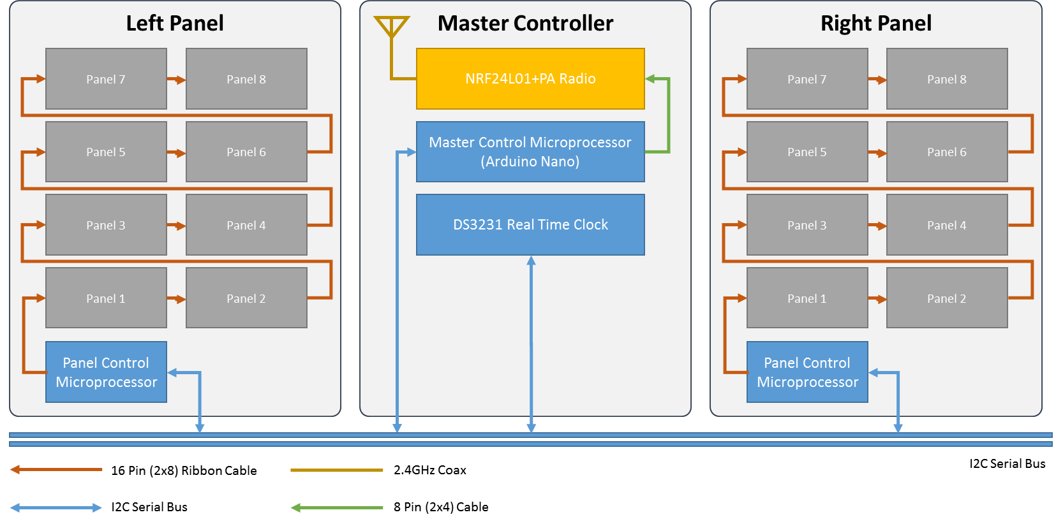

## SCORE DISPLAY POWER LAYOUT

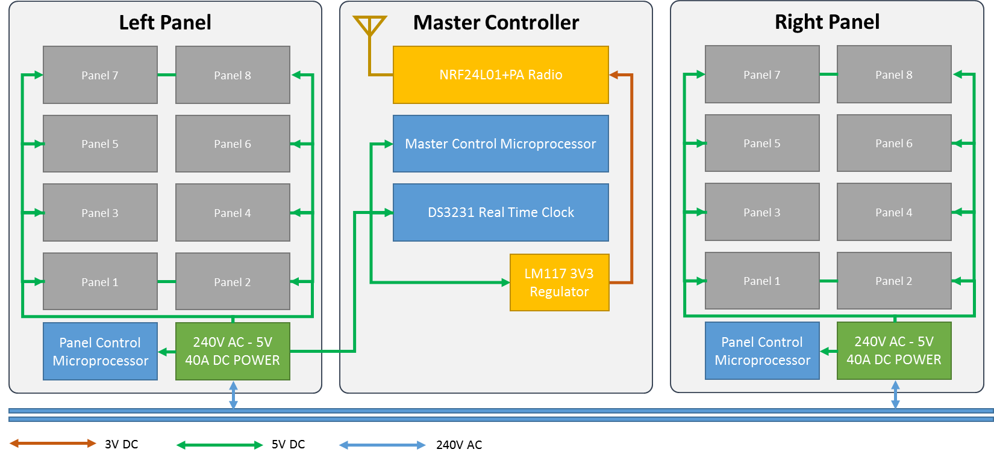

## SPONSORS DISPLAY LOGICAL AND POWER LAYOUT

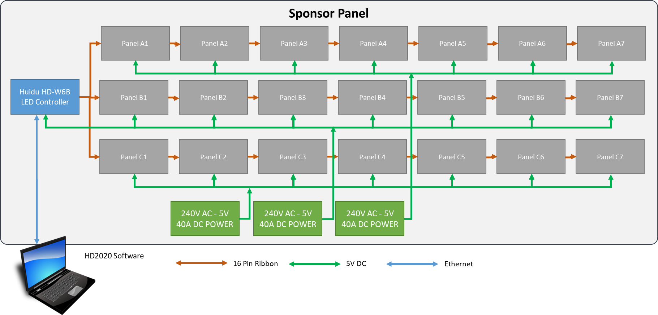

## MASTER & PANEL MICROPROCESSOR PCB

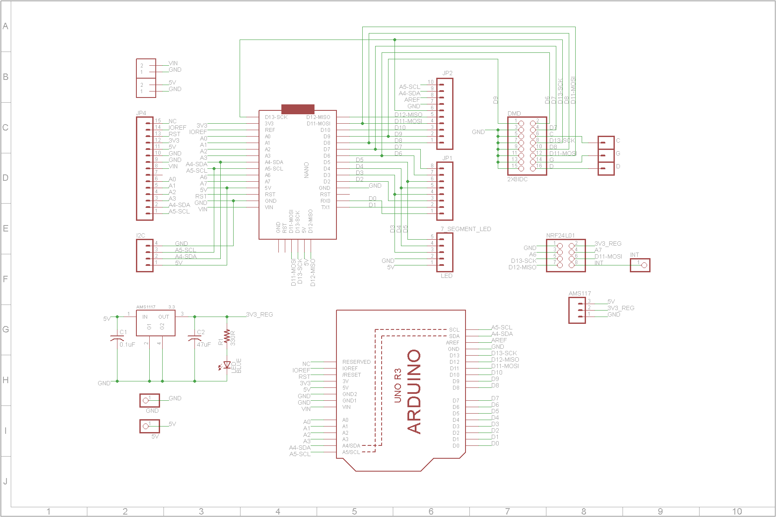

## WIFI CONTROLLER PCB

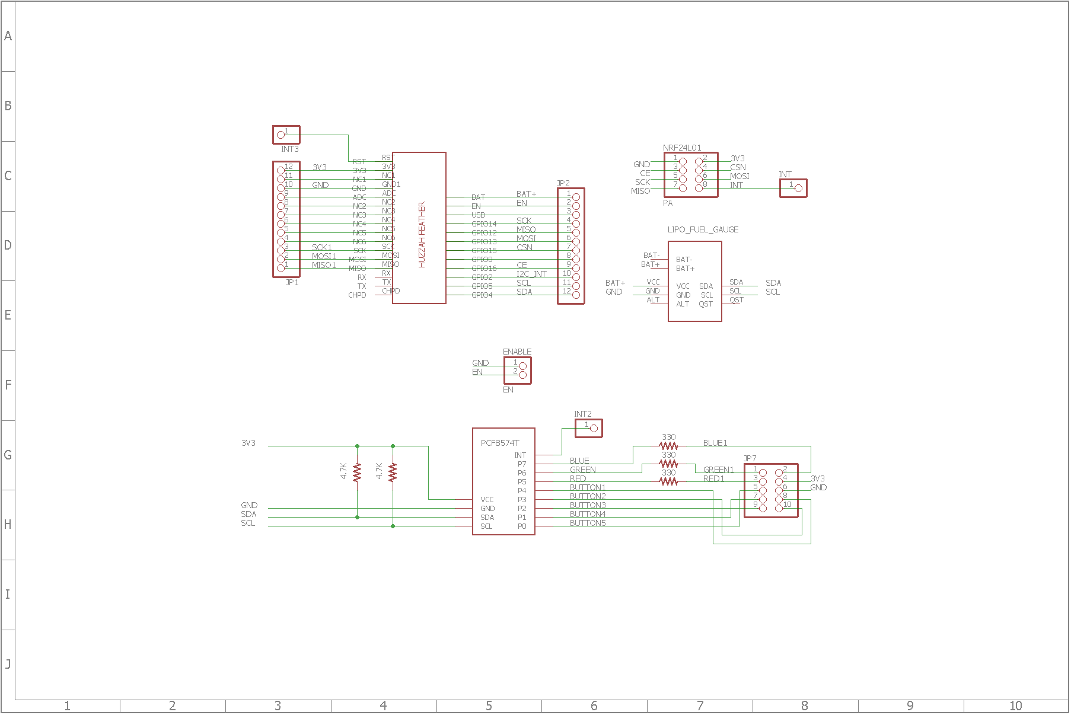

# HARDWARE AND PARTS

* The scoreboard is mostly built from widely available hardware (eBay, AliExpress etc) with custom printed circuit boards for integration/interfacing of the microcontrollers.
* The tables below list major components – other items used in construction are easily replaceable/repairable.

## SCORE DISPLAY

|  |  |  |  |
| --- | --- | --- | --- |
| **Key Components** | **Quantity** | **Description and Specification** | **Source** |
| LED Panels – White | 2 per display | 32x16 single color LED DMD panel  10mm pitch (P10)  Waterproof / Outdoor  10 pin SPI Interface / 5V Power  http://i.ebayimg.com/images/g/nPIAAOSwwbdWGWay/s-l1600.jpg | [Aliexpress](http://www.aliexpress.com/wholesale?catId=0&initiative_id=SB_20160820043909&SearchText=p10+outdoor+led+module) |
| LED Panels – Blue | 6 per display |
| Microprocessor Module | 1 per panel plus 1 for controller (3 total) | Arduino Nano (ATMEL ATMega328P) V3.2  (do not use V3.1 or below as pinouts are different)  http://store.iteadstudio.com/images/icon/arduinonano.jpg | [Ebay](http://www.ebay.com.au/sch/i.html?_from=R40&_trksid=p2050601.m570.l1313.TR4.TRC2.A0.H0.Xarduino+nano.TRS0&_nkw=arduino+nano&_sacat=0) |
| Circuit Board | 1 per panel plus 1 for controller (3 total) | Custom circuit board (see downloads below for schematic) | Custom PCB – see Eagle files |
| Voltage Regulator | 1 for main controller | AMS1117 3.3V 3V3 800mA Voltage Regulator  http://i.ebayimg.com/images/g/sOQAAOSwgQ9Vu8wq/s-l300.jpg | [Ebay](http://www.ebay.com.au/sch/i.html?_odkw=ams1117&_osacat=0&_from=R40&_trksid=p2045573.m570.l1313.TR0.TRC0.H0.Xams1117+3.3.TRS0&_nkw=ams1117+3.3&_sacat=0) |
| Radio Transmitter | 1 for main scoreboard / 1 for each handheld controller (3 total) | NRF24L01+ with high power amp  https://www.mysensors.org/radio/antenna.png | [Ebay](http://www.ebay.com.au/sch/i.html?_odkw=NRF24L01%2B&_osacat=0&_from=R40&_trksid=p2045573.m570.l1313.TR0.TRC0.H0.XNRF24L01%2B+PA.TRS0&_nkw=NRF24L01%2B+PA&_sacat=0) |
| Real Time Clock | 1 for main scoreboard | DS3231 AT24C32 IIC Precision RTC Real Time Clock Memory Module | [Ebay](http://www.ebay.com.au/sch/i.html?_odkw=DS3221&_osacat=0&_from=R40&_trksid=p2045573.m570.l1313.TR0.TRC0.H0.XDS3231.TRS0&_nkw=DS3231&_sacat=0) |
| Power Supply | 1 per display panel (2 total) | 110V-240V AC-DC 5V 40A LED Light Switching Power Supply Universal Transformer  Each power supply feeds up to 8 LED panels @ 4A each = up to 36A total load  Must be fanless (fans will fail)  http://i.ebayimg.com/images/g/HGMAAOSwZ1lWg2kh/s-l500.jpg | [Ebay](http://www.ebay.com.au/sch/i.html?_odkw=DS3231&_osacat=0&_from=R40&_trksid=p2045573.m570.l1313.TR12.TRC2.A0.H0.X5V+40A.TRS0&_nkw=5V+40A&_sacat=0) |
| Power wiring | As required | Must be able to carry 4A per panel connected (each panel draws approx. 4Amps peak when all LED’s are on) | Ebay |
| Data wiring | As required | 10 core ribbon cable | Jaycar |

## SPONSORS DISPLAY

|  |  |  |  |
| --- | --- | --- | --- |
| **Key Components** | **Quantity** | **Description and Specification** | **Source** |
| LED Panels – Blue | 21 per display | 32x16 single color LED DMD panel  10mm pitch (P10)  Semi-waterproof / Outdoor  10 pin SPI Interface  http://i.ebayimg.com/images/g/nPIAAOSwwbdWGWay/s-l1600.jpg | [Aliexpress](http://www.aliexpress.com/wholesale?catId=0&initiative_id=SB_20160820043909&SearchText=p10+outdoor+led+module) |
| Controller Module | 1 unit runs both displays | Huidu W6B  A close-up of a computer chip  Description automatically generated  May be substituted for any commercially available controller capable of running 3 x rows of 224 x 16 pixels | Aliexpress |
| Power Supply | 3 total | 110V-240V AC-DC 5V 40A LED Light Switching Power Supply Universal Transformer  Each power supply feeds up to 8 LED panels @ 4A each = up to 36A total load  Must be fanless (fans will fail)  http://i.ebayimg.com/images/g/HGMAAOSwZ1lWg2kh/s-l500.jpg | [Ebay](http://www.ebay.com.au/sch/i.html?_odkw=DS3231&_osacat=0&_from=R40&_trksid=p2045573.m570.l1313.TR12.TRC2.A0.H0.X5V+40A.TRS0&_nkw=5V+40A&_sacat=0) |
| Power wiring | As required | Must be able to carry 4A per panel connected (each panel draws approx. 4Amps peak when all LED’s are on) | Ebay |
| Data wiring | As required | 10 core ribbon cable | Jaycar |

## WIFI CONTROLLER

|  |  |  |  |
| --- | --- | --- | --- |
| **Key Components** | **Quantity** | **Description and Specification** | **Source** |
| Microprocessor Module | 1 per controller | Adafruit Feather Huzzah With Esp8266 Wifi  <https://www.adafruit.com/product/2821>  http://media.rs-online.com/t_large/R1245505-02.jpg | [Little Bird Electronics](https://littlebirdelectronics.com.au/) |
| Circuit Board | 1 for controller | Custom circuit board (see downloads below for schematic) | Custom PCB – see Eagle files |
| Radio Transmitter | 1 ea | NRF24L01+ with high power amp, SMA Antenna  https://www.mysensors.org/radio/antenna.png | [Ebay](http://www.ebay.com.au/sch/i.html?_odkw=NRF24L01%2B&_osacat=0&_from=R40&_trksid=p2045573.m570.l1313.TR0.TRC0.H0.XNRF24L01%2B+PA.TRS0&_nkw=NRF24L01%2B+PA&_sacat=0) |
| Lipo Battery Monitor | 1 ea | SparkFun LiPo Fuel Gauge (MAX17043G+U)  SparkFun LiPo Fuel Gauge | [Little Bird Electronics](https://littlebirdelectronics.com.au/) |
| I2C IO Port Expander | 1 ea | Pcf8574 Pcf8574t I2c 8 Bit Io Gpio Expander Module  (RED VERSION AS SHOWN BELOW / DO NOT BUY THE BLUE VERSION)  Image result for pcf io expander | [Ebay](http://www.ebay.com.au/itm/PCF8574T-I-O-I2C-Port-Interface-Support-Arduino-Cascading-Extended-Module-/191736125266?hash=item2ca45d1752:g:PNIAAOSwGotWlv-Q) |
| LiPo Battery | 1 ea | 3.7V Polymer Lithium Ion Battery - 1000mAh with JSF connector for HUZZAH Feather  Battery MUST include low voltage protection  3.7V Polymer Lithium Ion Battery - 1000mAh FIT0120 DFRobot Australia - Express Post Australia Wide (Feature image) | [Little Bird Electronics](https://littlebirdelectronics.com.au/) |
| Other components | 1 ea | SMA antenna pigtail  SMA faceplate connector  4.7K Resistors x 2  330 Ohm Resistors x 3  Momentary pushbutton switches x 4  Rocker switch x 1  Hookup wire  Laser cut front panel  RGB LED  Panel mount USB Type B socket to micro-USB plug | Jaycar, various |

# DESIGN FILES

Design files are available on GitHub here -> <https://github.com/plainolddave/Scoreboard>

To view detailed designs, download the following software packages:

* Source Code – Visual Studio 2017 (C++)
* PCB Layout – Eagle PCB version 7.0 or higher - <https://www.autodesk.com/products/eagle/overview>
* 3D Design – Solidworks 2017 SP5 or higher - <http://www.solidworks.com/>

# PROGRAMMING

## SOFTWARE DEVELOPMENT ENVIRONMENT

All software was developed on a Windows PC using the following tools (current as of July 2017).

### Microsoft Visual Studio Community 2017 (C/C++)

Visual Studio is licensed free from Microsoft available from <https://www.visualstudio.com/en-us/downloads/download-visual-studio-vs.aspx>

### Visual Micro

Visual Micro is a toolset that integrates into Visual studio, available from <http://www.visualmicro.com/> . You also need the Arduino IDE for Visual Micro to function correctly.

### Arduino IDE

Arduino is a widely used development environment available from <https://www.arduino.cc/> . The code should (perhaps) compile using Arduino IDE alone as it uses the same underlying GCC compiler as Visual Micro. In practice however Visual Studio/Visual Micro are far easier and provides many useful debugging tools (compile and upload solely using the Arduino IDE has not recently been tested).

### Touchscreen

The touchscreen is a stand-alone display processor that’s reasonably powerful in its own right. The software is developed using the WorkShop 4 IDE from 4D Systems available at <http://www.4dsystems.com.au/product/4D_Workshop_4_IDE/>

## SOFTWARE LIBRARIES

C++ Libraries are all downloadable from <https://github.com/plainolddave/Scoreboard/tree/master/Design/Firmware/Arduino_Libraries>

Instructions to install the libraries in the correct folder for Arduino are here <https://www.arduino.cc/en/Guide/Libraries>

## SOURCE CODE

All source code is available here:

<https://github.com/plainolddave/Scoreboard/tree/master/Design/Firmware>